**Project Of TravelTrax Tours**

Introduction:**Tourism** is [travel](https://en.wikipedia.org/wiki/Travel) for pleasure or business, and the commercial activity of providing and supporting such travel.[[1]](https://en.wikipedia.org/wiki/Tourism#cite_note-1) The [World Tourism Organization](https://en.wikipedia.org/wiki/World_Tourism_Organization) defines tourism more generally, in terms which go "beyond the common perception of tourism as being limited to holiday activity only", as people "travelling to and staying in places outside their usual environment for not more than one consecutive year for [leisure](https://en.wikipedia.org/wiki/Leisure) and not less than 24 hours, business and other purposes".[[2]](https://en.wikipedia.org/wiki/Tourism#cite_note-unwto1034-2) Tourism can be [domestic](https://en.wikipedia.org/wiki/Domestic_tourism) (within the traveller's own country) or [international](https://en.wikipedia.org/wiki/International_tourism), and international tourism has both incoming and outgoing implications on a country's [balance of payments](https://en.wikipedia.org/wiki/Balance_of_payments).

Overview:

The travel and tourism industry refers to a collection of businesses and organizations that offer products and services to people who are traveling away from their homes for leisure, business, or other purposes. This industry includes a wide range of activities, such as transportation, accommodation, food and beverage services, attractions, and travel services. The travel and tourism industry is a complex and multifaceted sector that plays an essential role in promoting economic growth, cultural exchange, and global connectivity. In the rest of this article, we are going to present you with an overview of the travel and tourism industry.

Purpose:

Tourism industry is important for the benefits it brings and due to its role as a commercial activity that creates demand and growth for many more industries. Tourism not only contributes towards more economic activities but also generates more employment, revenues and play a significant role in development.

Tourism is an individual activity of traveling and visiting places. It has created and promoted different [styles or types of travelling](https://market-width.com/blogs/types-travel-important.htm), and travelers. We call these travelers as tourists who visit different tourist places and destinations. These tourists want to and they travel to places and make those places more popular. This way they bring earning opportunities. They also encourage development of those places, the nearby places and in fact the whole country or region to facilitate growing tourist activities.

Problem Definition & Design Thinking:

Top challenges confronting tourism are taxation, travel marketing, infrastructure issues, and security and cross border regulations. Too many tourism destinations are not prepared for visitors. Tourists or travelers can at times deem travel marketing to be exaggerated. Another major challenge that the tourism industry faces is the fluctuating rates and cost inflation. New challenges seem to arise quickly impacting the industry as a whole.

**Empathy Map**

An empathy map is a simple, easy-to-digest visual that captures knowledge about a user’s behaviors and attitudes. It is a useful tool to helps teams better understand their users. Empathy mapping is a simple workshop activity that can be done with stakeholders, marketing and sales, product development, or creative teams to build empathy for end users. For teams involved in the design and engineering of products, services, or experiences, an empathy mapping session is a great exercise for groups to “get inside the heads” of users.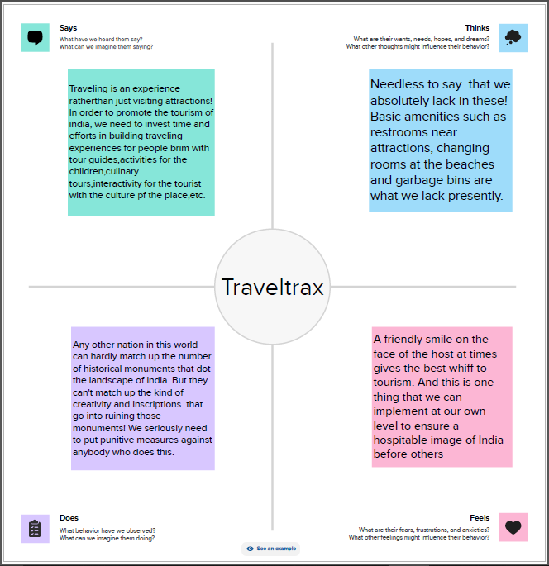

**BrainStorming Map:**

Brainstorming is a group problem-solving method that involves the spontaneous contribution of creative ideas and solutions. This technique requires intensive, freewheeling discussion in which every member of the group is encouraged to think aloud and suggest as many ideas as possible based on their diverse knowledge.

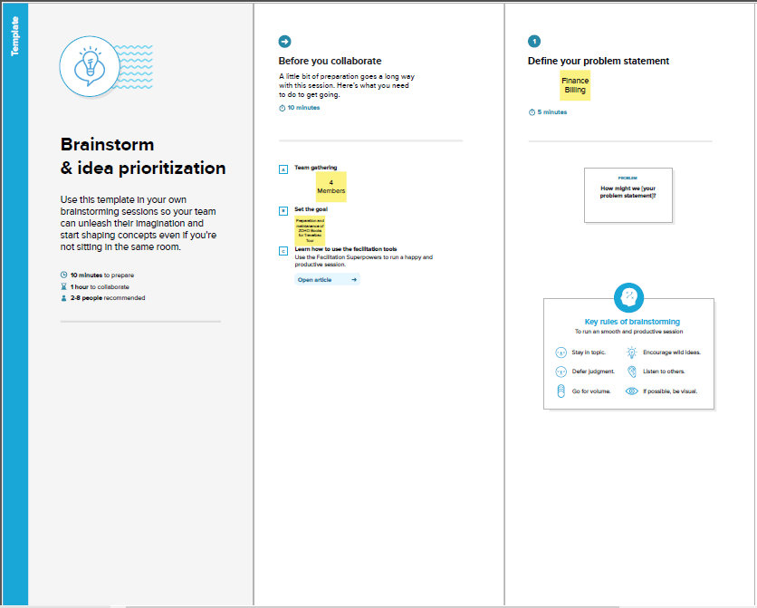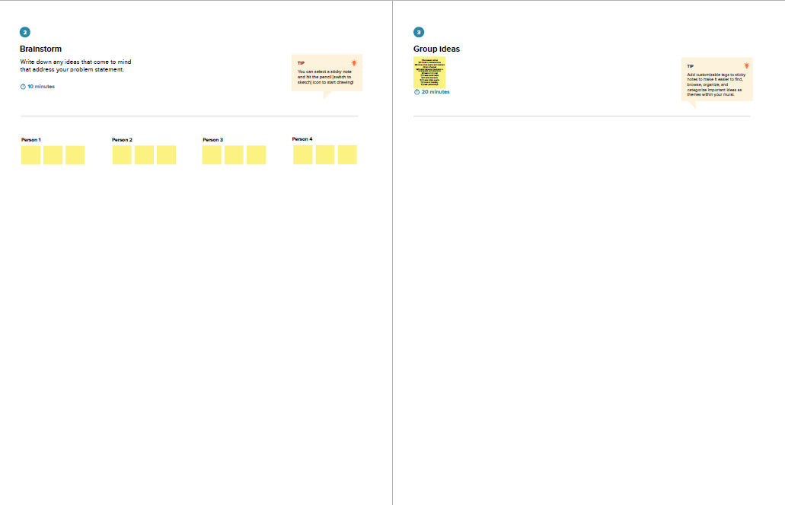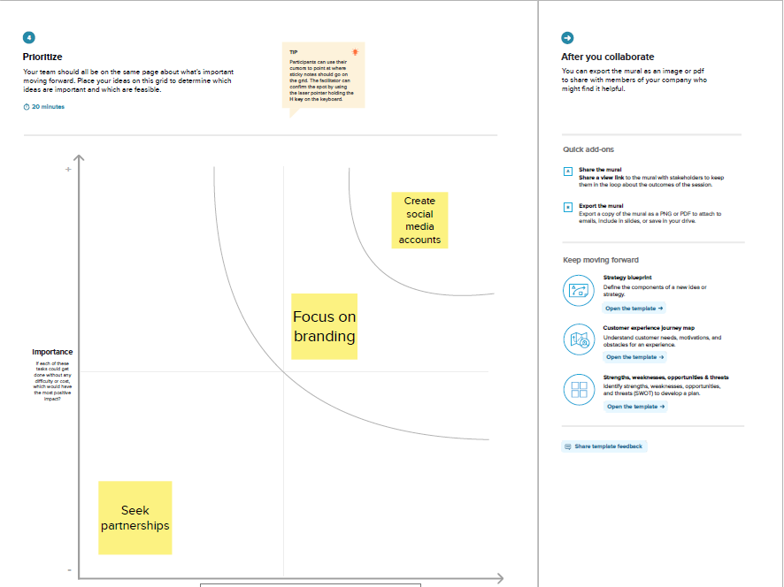

**Result:**

Balance sheet of our Project “**TravelTrax Tours**”

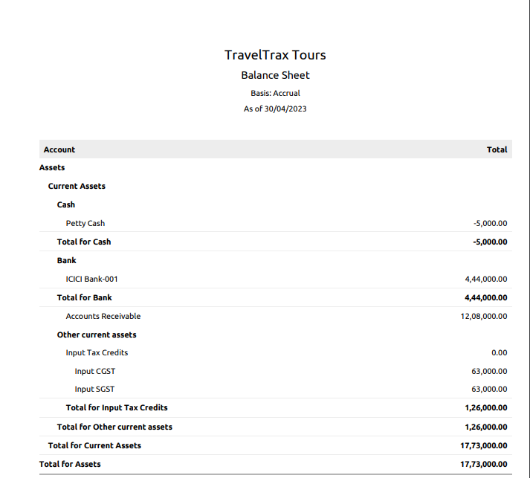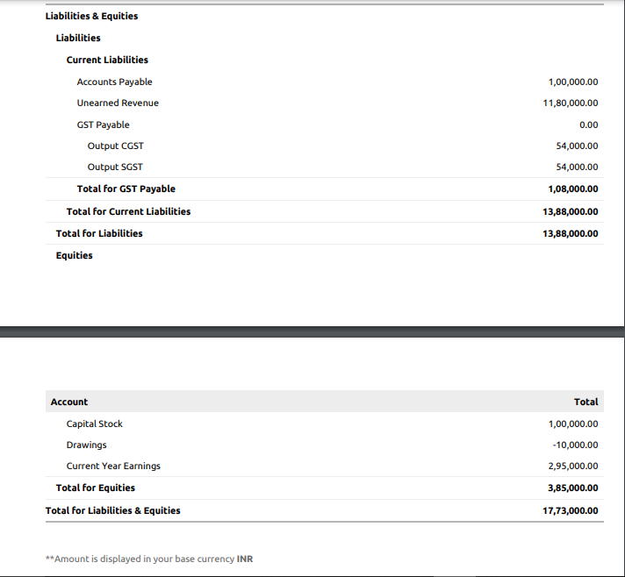

**Profit and Loss**

Basis: Accrual

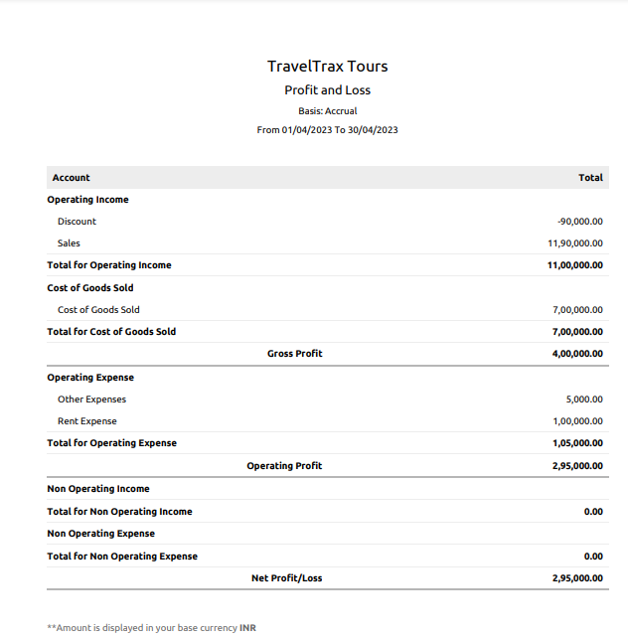

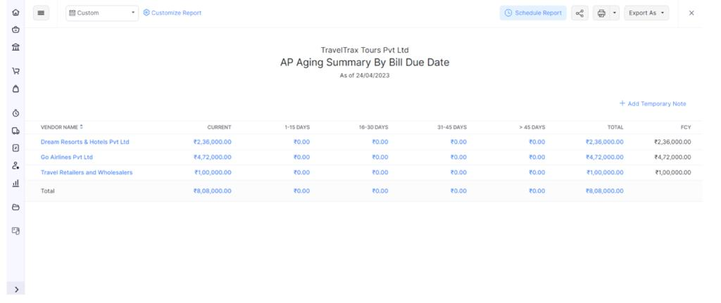

**Advantages of this Concluding solutions:**

It is the responsibility of the tourism department or organization to make it possible for people to travel to and go on vacation in desired locations. Any nation's tourism industry is one of its most vital sectors. It makes a significant contribution to the economy of a nation because it can generate income all year long. As a result of the tourism industry, many jobs are created, aiding in maintaining a stable employment rate for nations.

**1.Rapidly increasing the Economic Growth**

**2.The Development of a whole Country**

**3.Various Employment Creation**

**4. Unification of Various Socities in the country**

**5. Preservation and Protection for all peoples**

**Disadvantages of this concluding solutions:**

**Even with all of the advantages of tourism, there are still a number of disadvantages. The tourism industry of that nation occasionally disregards these drawbacks because profit is their only motivation. All aspects of tourism, such as its impact on the environment, financial viability, and sustainability, must be taken into account. We'll explore some of the advantages and disadvantages of tourism presently.**

**1. Tourists' Negligence of the Environment**

**2. Exploitation of Local Culture**

**3. Tourists' Lack of Compliance**

**4. Lack of Job Security/Seasonal only**

**5. Limited to Service-only Jobs**

**Application:**

The application where we used to solve those problems are as follows;

**Github:GitHub is an increasingly popular** [**programming**](https://www.simplilearn.com/how-to-learn-programming-article) **resource used for code sharing. It's a social networking site for** [**programmers**](https://www.simplilearn.com/how-to-become-programmer-article) **that many companies and organizations use to facilitate project management and collaboration. According to** [**statistics collected in October 2020**](https://octoverse.github.com/)**, it is the most prominent source code host, with over 60 million new repositories created in 2020 and boasting over 56 million total developers.**

**Zoho Books:Zoho Books is a smart online accounting software designed to help businesses streamline their back office operations, automate business workflows, and help securely collaborate with accountants online. It is designed for all business sizes,**

**Conclusion:**

Tourism is not all bad. The education that can come about when travelling and interacting can be greater than that gained from any textbook. Travelling does have its' downfalls which need to be made known so a solution can be found.

Tourism commodifies cultures and their associated businesses and goods. It effects the environment in many harmful ways, including the habitats of many endangered animals. Tourism can also overshadow or in the opposite direction drastically change the indigenous cultures of a place.

Tourists need to make sure they do everything in their power to prevent these negative effects of tourism. They should get vaccines, stay in designated areas, and respect and preserve the culture put before them. With these simple measure travelers of all ages can help reduce the footprints left behind by tourism.

**Future Scope:**

The World Travel and Tourism Council (WTTC) is an industry lobby group comprising the major tourism corporations in the world . As part of their work they have estimated the size and scope of the tourism industry using sophisticated economic techniques. They state that travel and tourism is one of the largest and most dynamic industries of today’s global economy (WTTC, 2017). The figures for 2016 speak for themselves:

The travel and tourism industry’s total percentage of world gross domestic product was 10.2%;

The world travel and tourism industry supported 292 million jobs (11% of all world jobs);

The world travel and tourism industry accounted for 6.6% of the world’s exports; and

There were almost 1.25 billion international tourism trips and over 6 billion domestic trips.

The question posed by these numbers is just how did the WTTC come up with these estimates, and what do they include as being a part of the travel and tourism industry? This key issue is occupying the minds of academics and politicians alike, as well as industry lobbyists such as the WTTC.

**Appendix:**

We get from the project

TravelTrax Tours

ZOHO Books

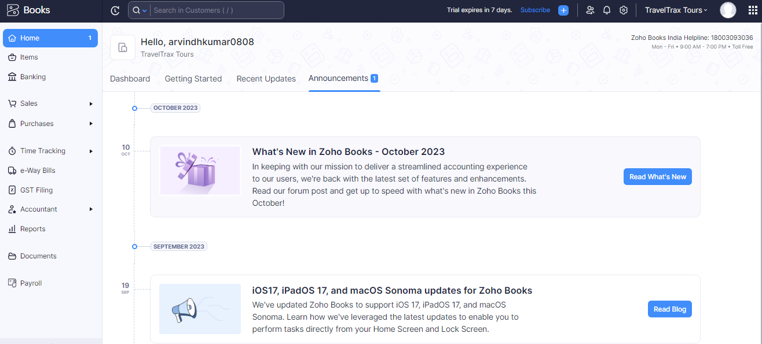

GitHub:<https://github.com/arvindhnmuser/traveltrackstour>

**Thank You**